Prototype and OES design choices

OES can work with out of the box attribute retrievers –
Some important points to keep in mind
-The attribute Retreivers are defined on the SM level which are the Policy Decision Points.

If WebServices SM is use then the only choice for the OOTB database attribute retriever will be to use the jdbc option.
- The better option will be to use Weblogic SM which then can use the Database pools.
- Web Services SM uses web services to distribute policy between the oes server and the SM. It does not change the mechanism for making the authorization calls. The authorization calls still can be either PEP API or xacml API.

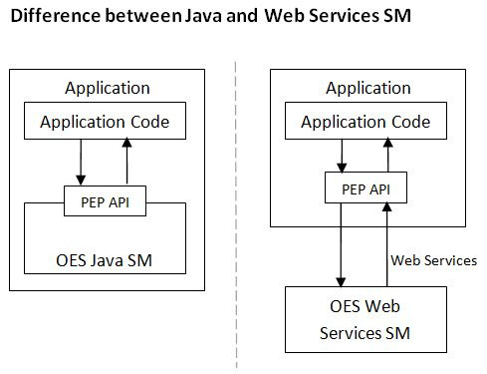
PEP API with Web Services SM makes a call like http://DW77604QM4SK1.cap.org:8901/Authorization to the PDP

For the Policy enforcer there are two choices for PEP API or XACML

